Name: محمد عادل عبدالوهاب محمد

B.N : 740

Github link : <https://github.com/mohamedadel46/ECE001>

Github pages published website

<https://mohamedadel46.github.io/ECE001/>.

Title :

Programming languages

Programming is an important field in science in this times because of the development of the technology.

So it was necessary to talk about the programming languages and the different between them and which one you should learn if you was keen on programming

Screenshots

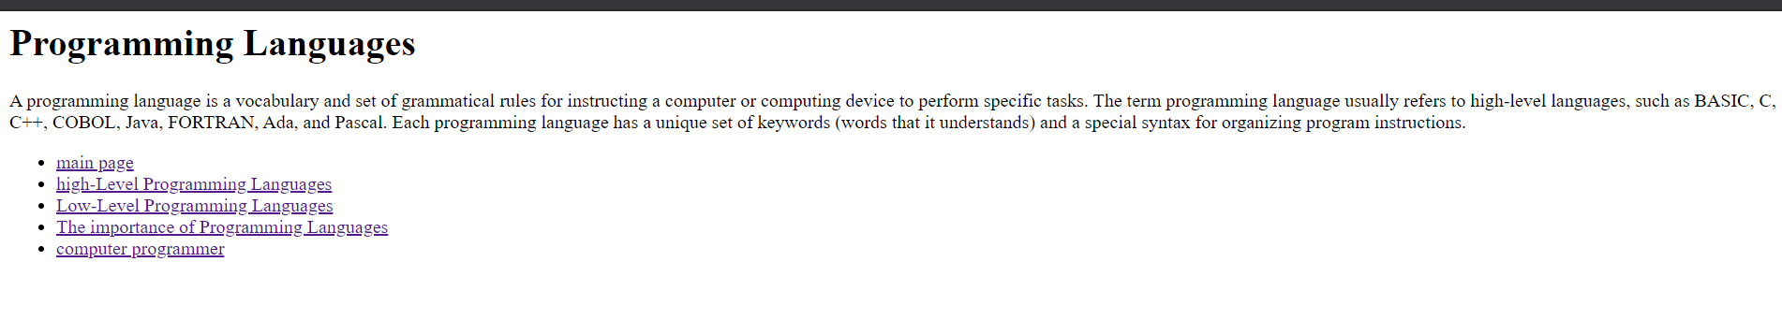

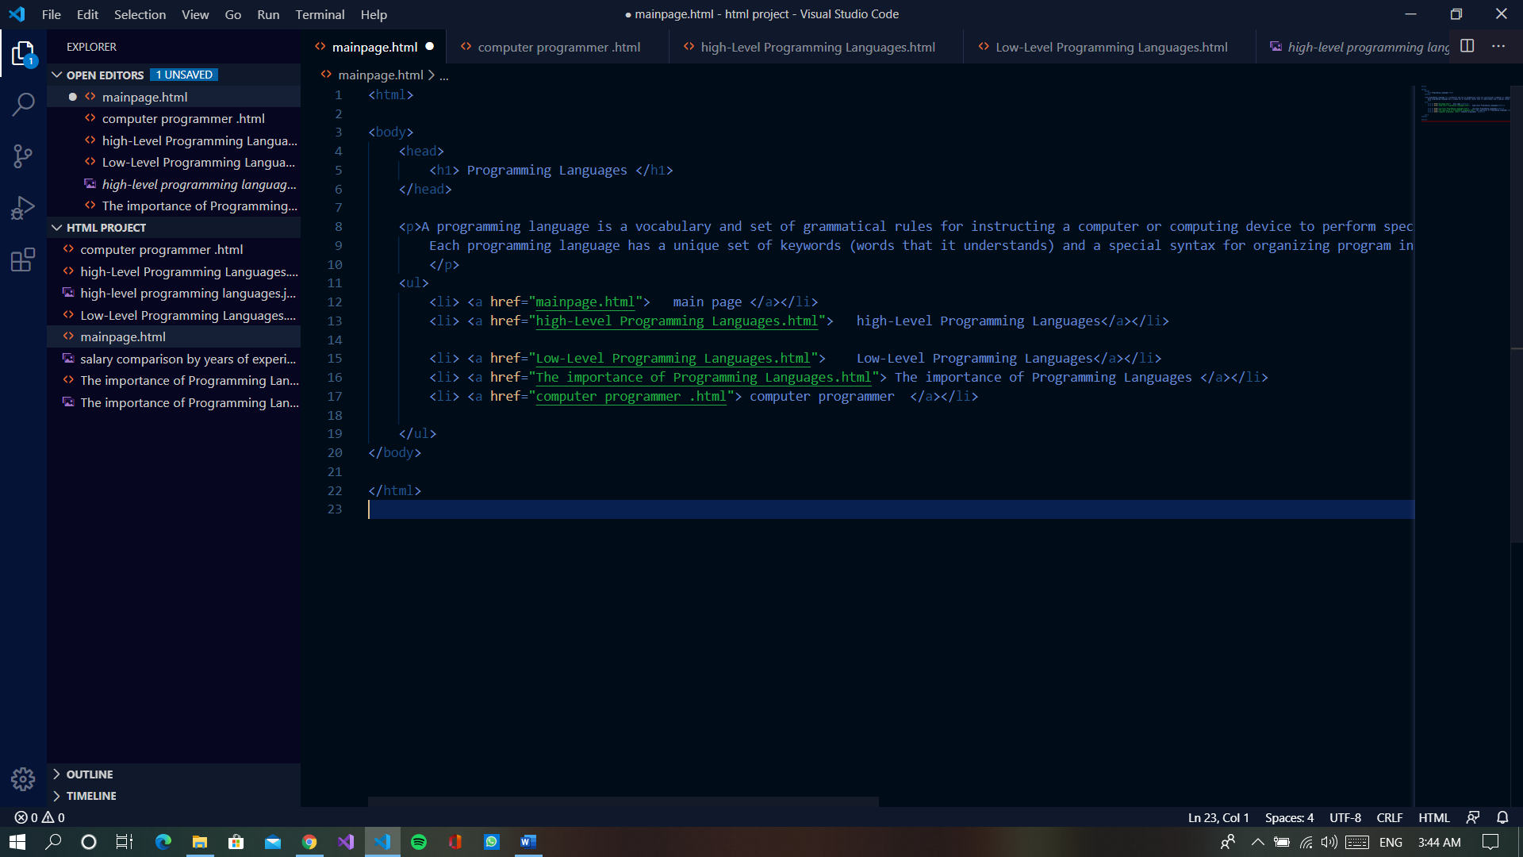source code

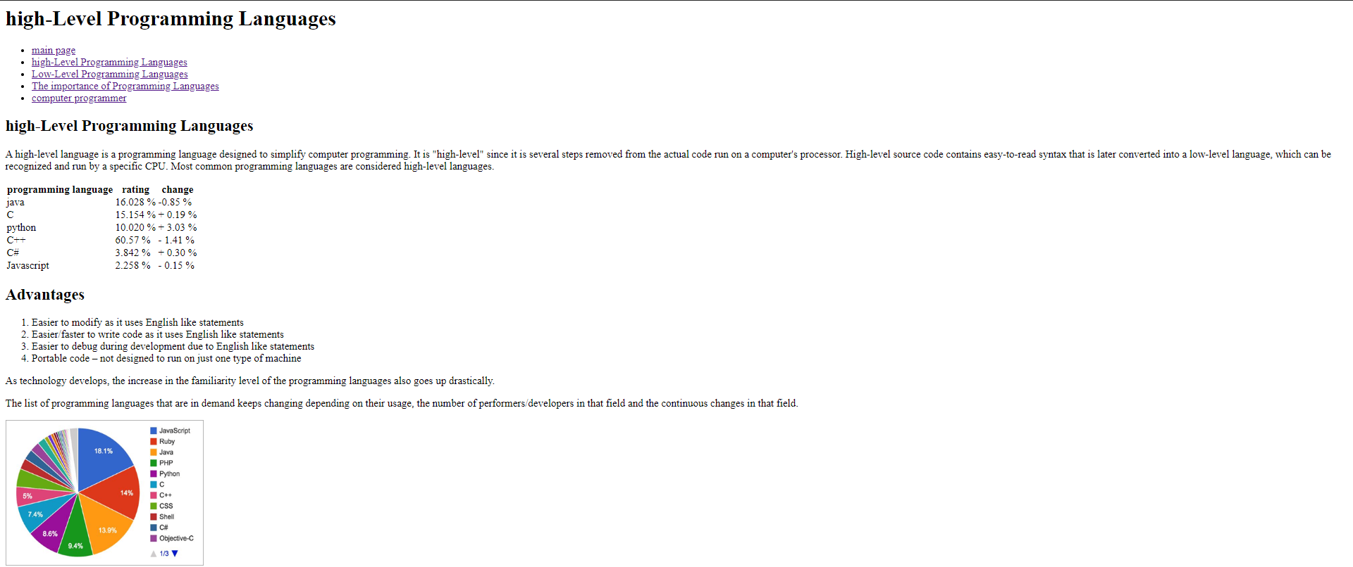

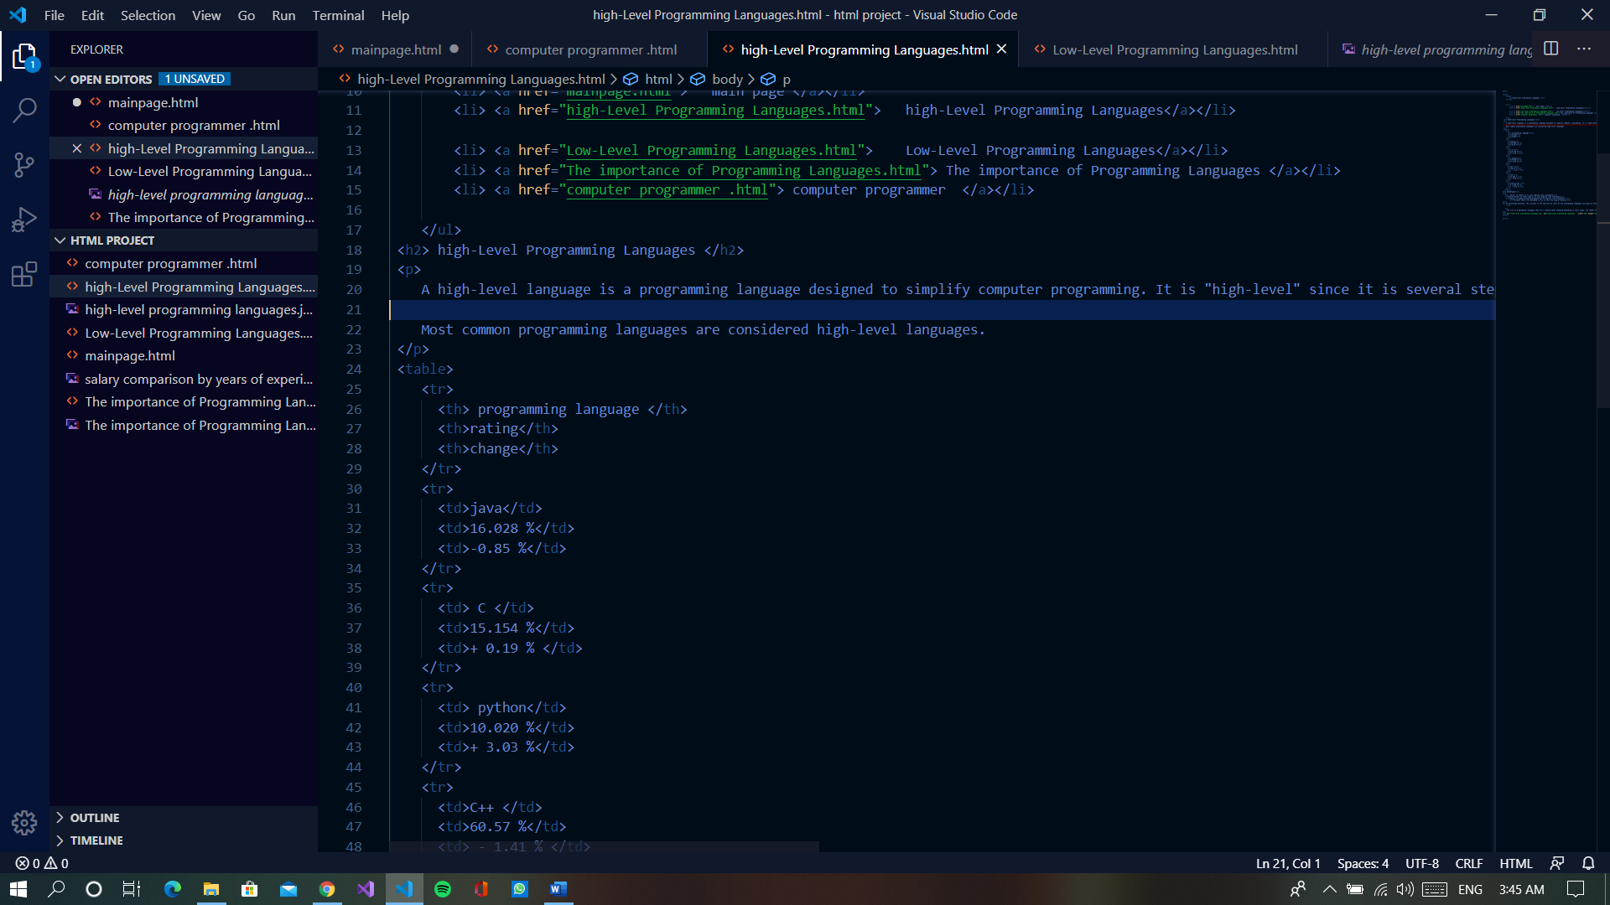source code

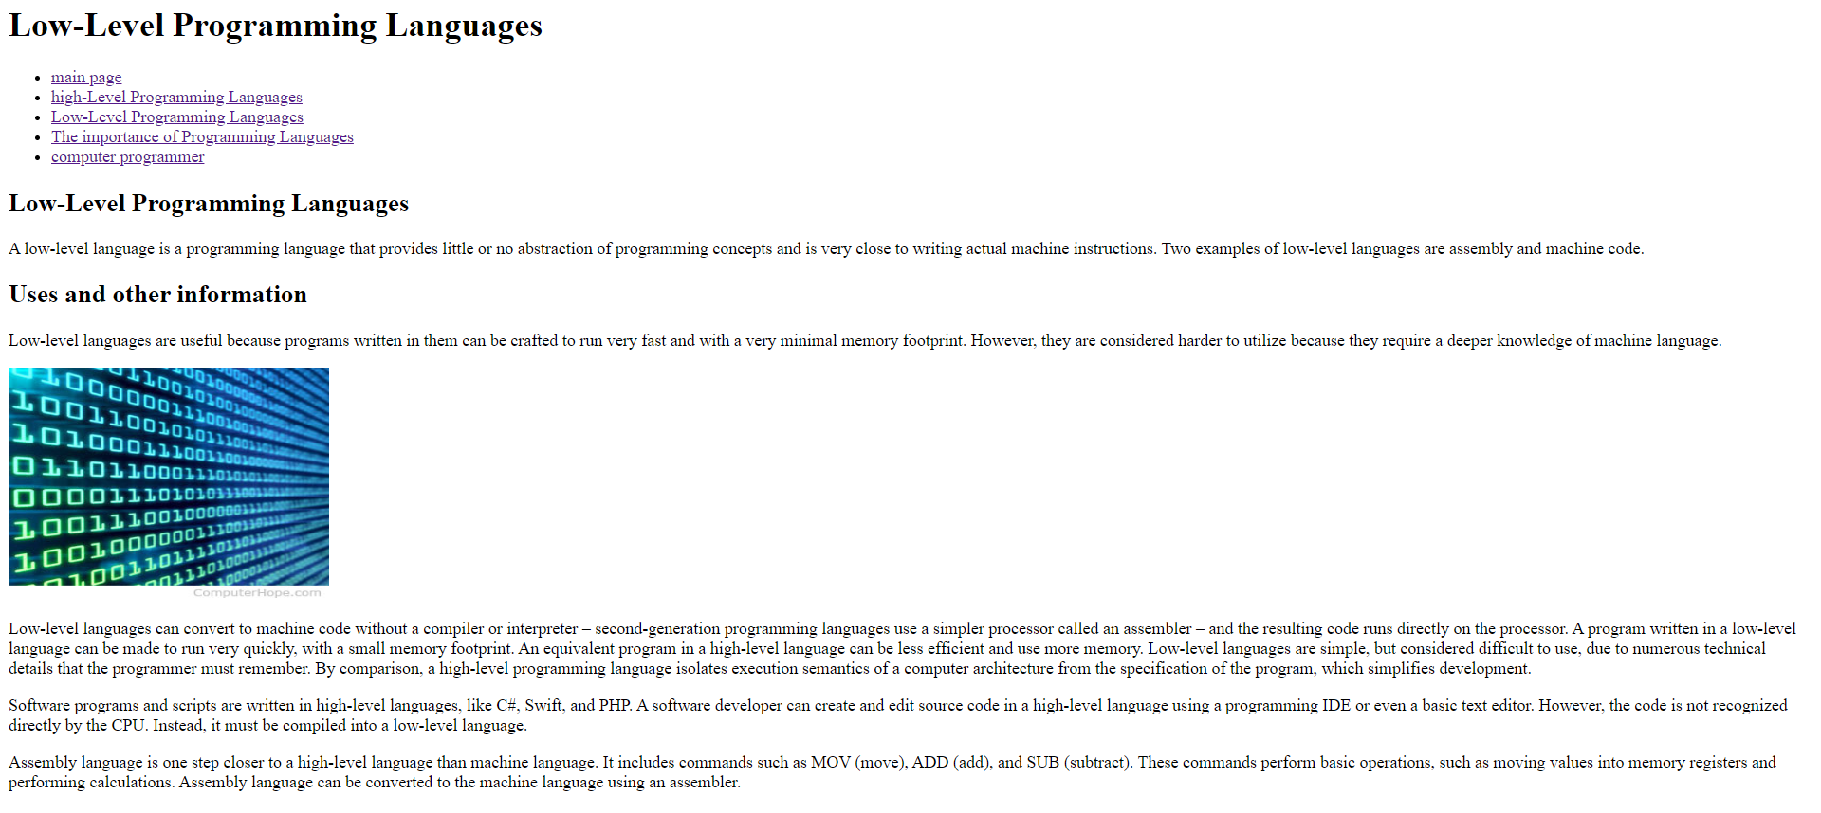source code

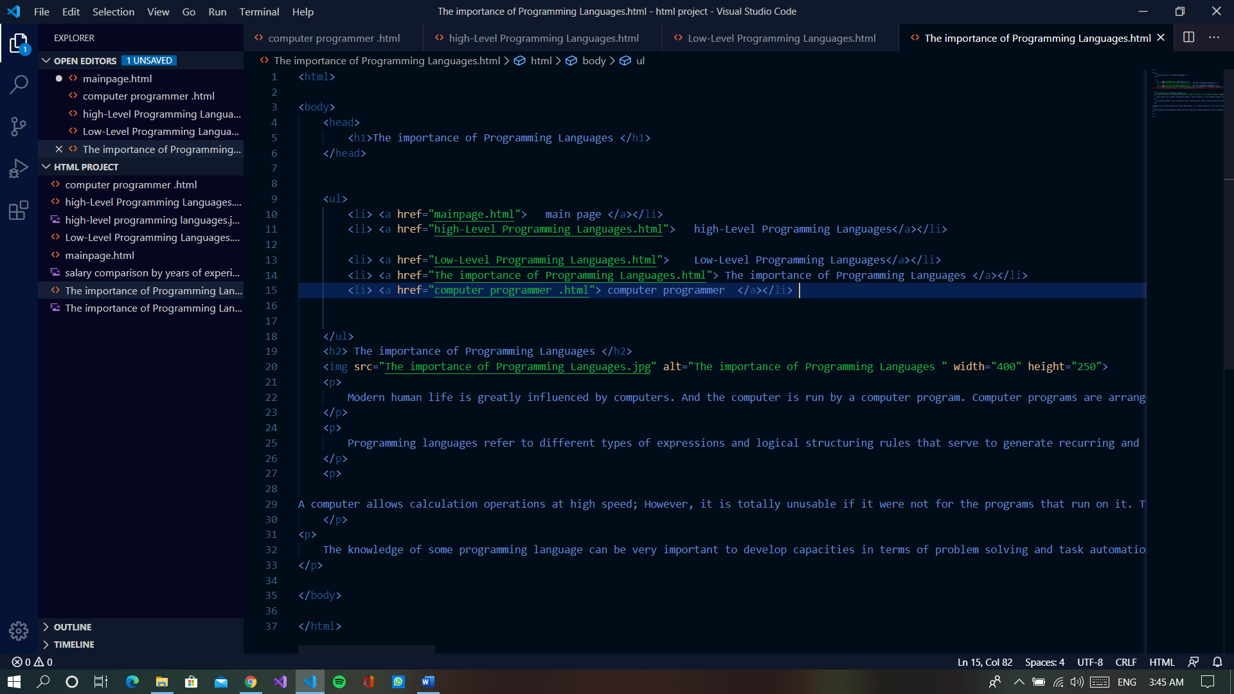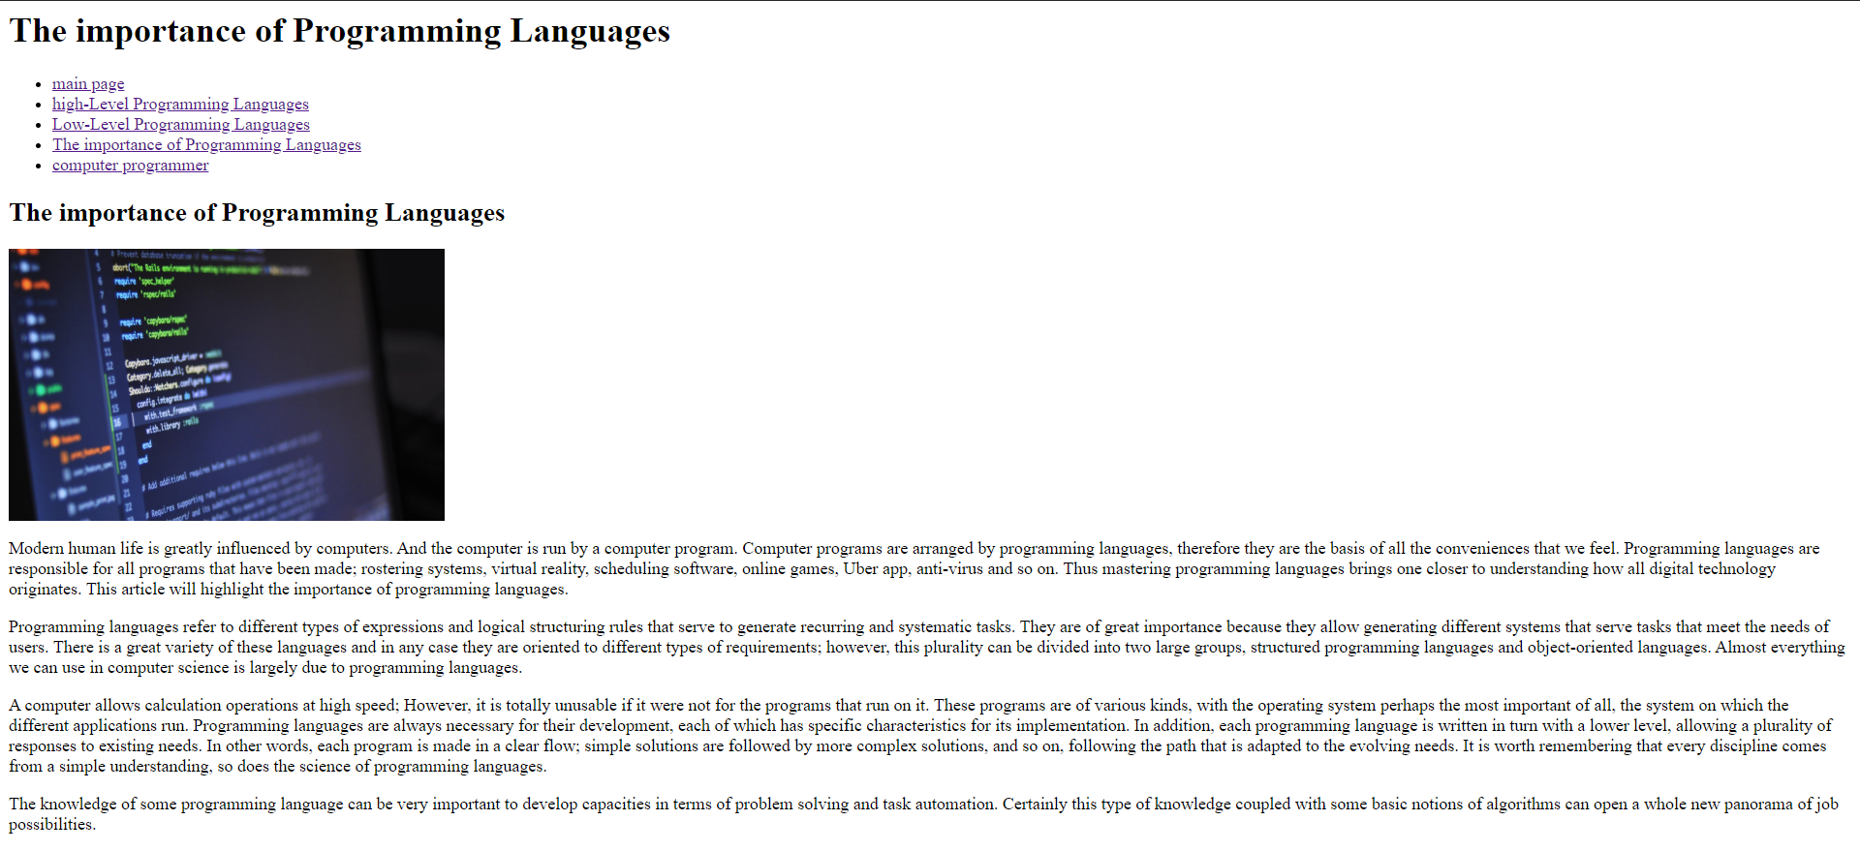source code

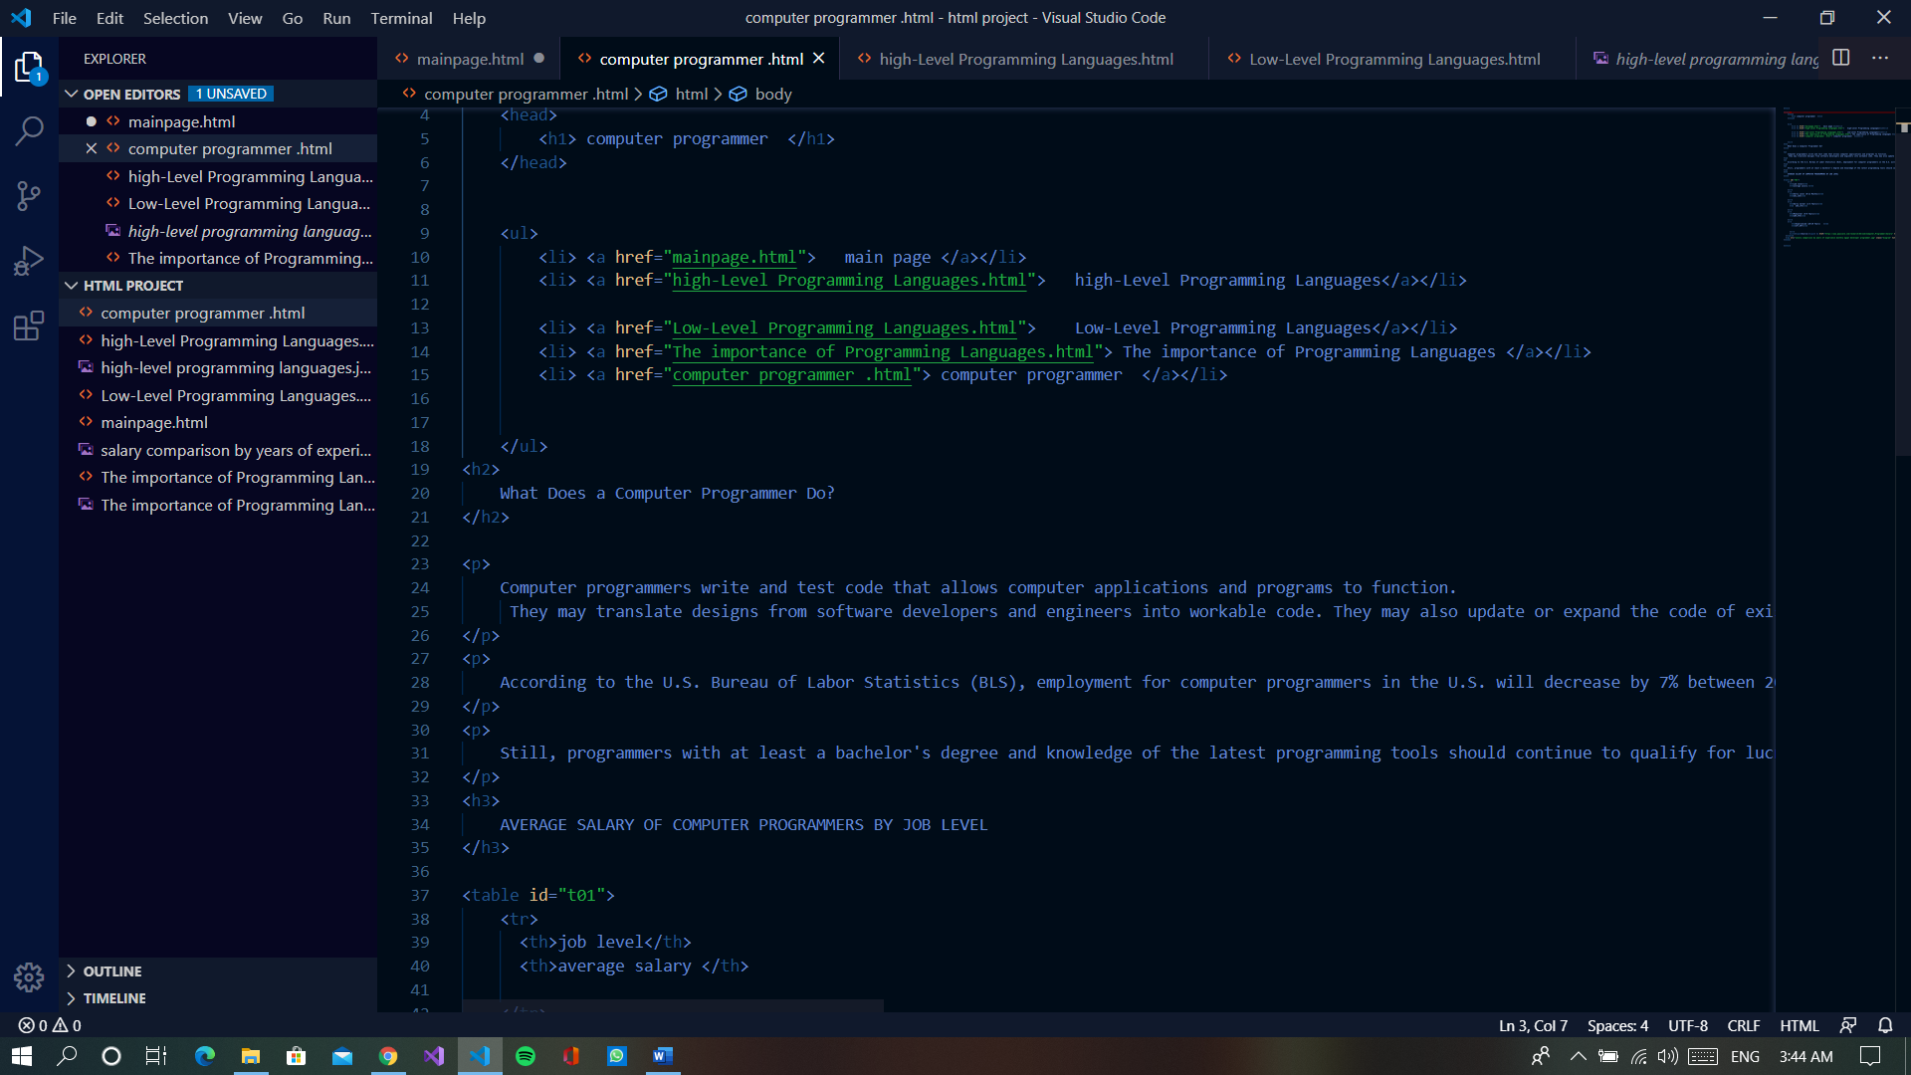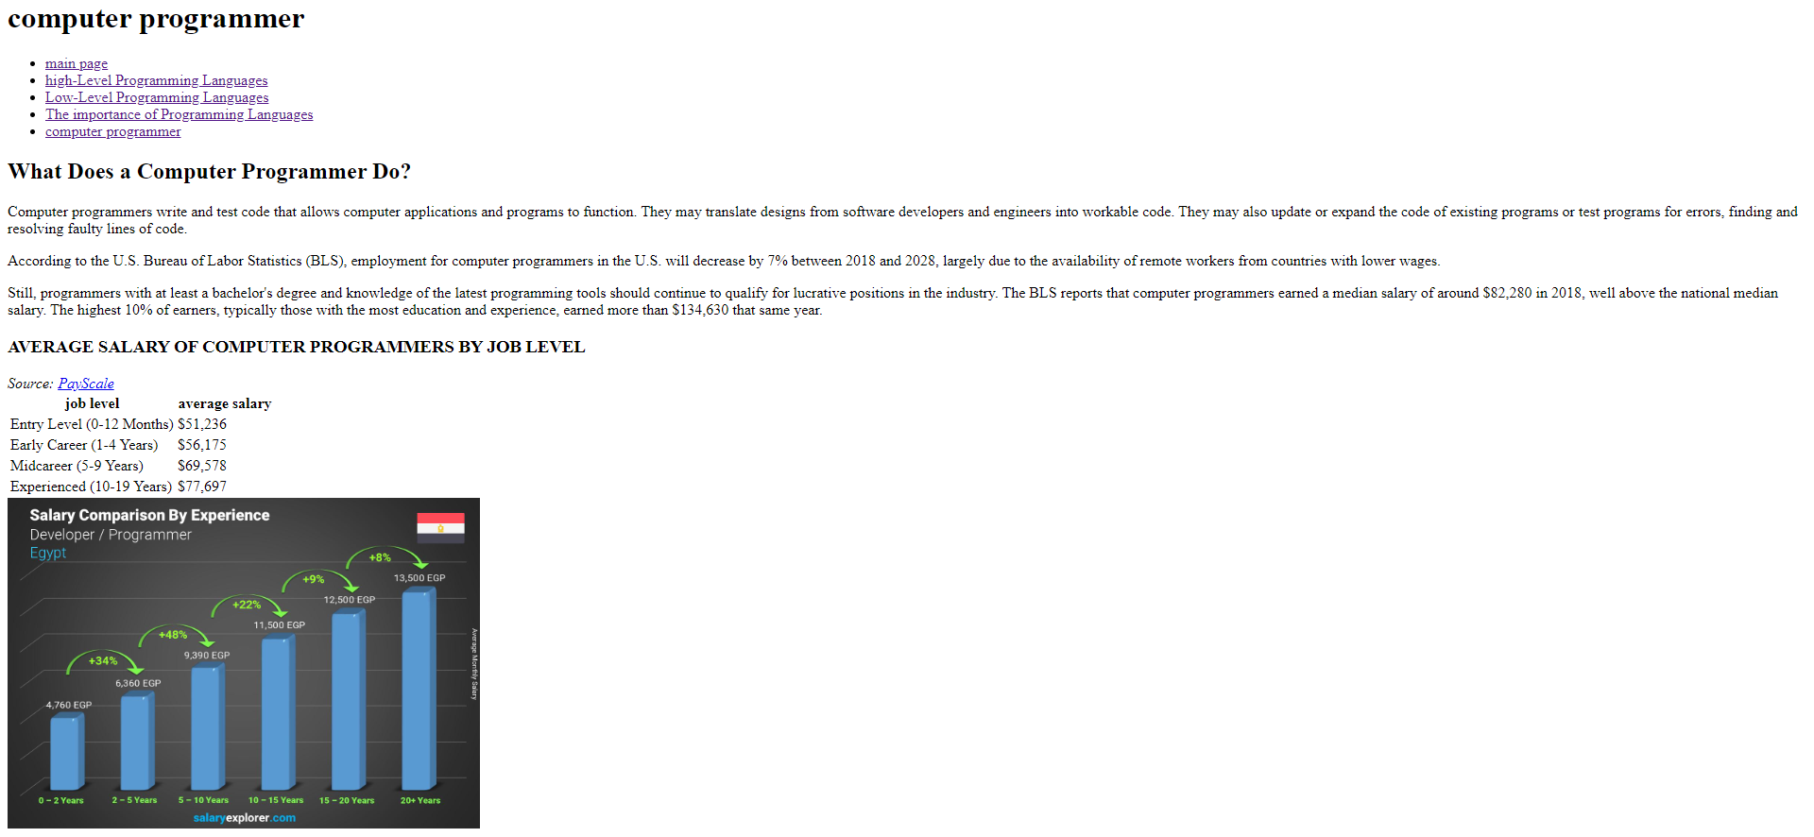source code

